Alg 4 Night Name: ____________________________

______________ _____________

WS Assessment

Target 5:

Polynomial function

**I can:**

* Determine polynomial function
* Identify the degree, roots type
* Write polynomial function

**Unit 6: Polynomials and Their graph**

* [**HSA.APR.A.1**](http://www.corestandards.org/Math/Content/HSA/APR/A/1/): Understand that polynomials form a system analogous to the integers, namely, they are closed under the operations of addition, subtraction, and multiplication; add, subtract, and multiply polynomials.
* [**HSA.APR.B.3**](http://www.corestandards.org/Math/Content/HSA/APR/B/3/): Identify zeros of polynomials when suitable factorizations are available, and use the zeros to construct a rough graph of the function defined by the polynomial.
* [**HSF.IF.C.7.C**](http://www.corestandards.org/Math/Content/HSF/IF/C/7/c/): Graph polynomial functions, identifying zeros when suitable factorizations are available, and showing end behavior.

Intro to Polynomial: Standard form: anxn + an-1xn-1 + … + a1x1 + ao

Power has to be positive integers. Degree is **n** and turning point is **n – 1** (change direction)

The roots of the polynomial are the value of x that makes polynomial = 0. It is also where the polynomial graphs cross or touch the x-axis

1. Which of the following are polynomial function? If it is, write the degree, if not explain

a. 3x3 + 2x2 + x b. (x – 1)2 (x – 2)2 c. x2 + 2

d. 3 e. x – 2-2 + 1 f.

g. h. + i. -7x4 + 2/3x3 + x2 – 4.1x – 6

j. 8 + 3.2x2 – πx5 – 6.1x10 k. 9x3 + 4x2 – 6x-1 + 7x l. x(x3 + 2)(x4 – 4 )

2. Sketch the following function, state the degree and identify its roots (x-intercept).

|  |  |  |
| --- | --- | --- |
| Adjust WINDOW |  |  |
| |  |  |  | | --- | --- | --- | | f(x) = x2 – 6x + 8 | f(x) = x3 – 8x + 6 | f(x) = x4 – 10x2 + 6 | |  |  |  |   Compare the following three function then sketch it shapes (no graphing device)   |  |  |  |  | | --- | --- | --- | --- | |  | f(x) = (x + 5)(x - 2) | f(x) = (x + 5)(x – 2)2 | f(x) = (x + 5)(x – 2)3 | | Simi-lar |  |  |  | | Diff-  erent |  |  |  | |  |  |  |  | |  |  |

Writing Polynomial: Sketch the graph that has

Single Roots Double Roots Triple Roots Complex Roots

y = x2 – 1 y = (x – 1)2 y = (x – 1)3 y = x2 + 1

State the degree, show the turning point(s), root(s), root’s type for the following graph function

|  |  |  |
| --- | --- | --- |
|  |  |  |
|  |  |  |

The root form of the polynomial y = A(x – root1)(x – root2)(x – root3)(x – root4) ….

Find the polynomial function that produce the following graph.

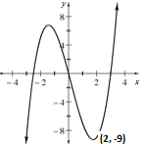

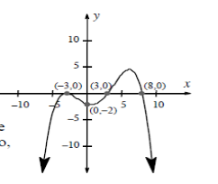Show me for stamp

Write a polynomial function has single root at $1±\sqrt{2}$, 2 and with y intercept at 3. Sketch a graph to check.

Write a polynomial has single root at 2, double root at -4 and pass through the point (5, 35). Sketch a graph to check.

Write the polynomial equation that has two roots x = 3i and x = -3i and y intercept 4.5.

Sketch the graph

Write the specific equation for the polynomial function passing through the point (0, 5), and with roots x = 5, x = -2, x = 3i and x = - 3i. Sketch the graph

Write the quadratic equation with two complex roots at x = ± 5i

Write the polynomial that has 2 real roots and two complex roots of your choice then sketch the graph. x = _________ x = _________ x = _________ x = _________

Write the polynomial function that has root at 3, 3i and 3 + i and y intercept at -540

Find the function for the following graph. Hint: One of its complex roots is 3i

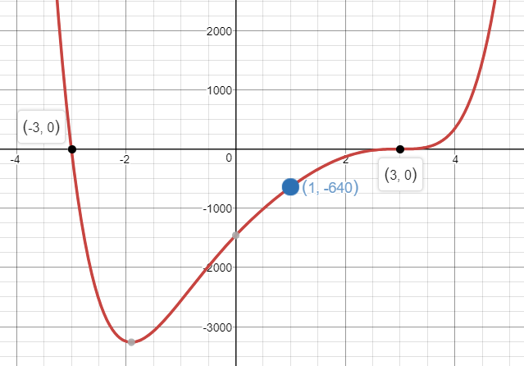

**Assessment Target 5**

**I can…** Identify, write and state the degree of polynomial.

Write the quadratic equation with two complex roots at x = ± 4i

Write the specific equation for the polynomial function passing through the point (0, 7), and with roots x = -5, x = 3, x = 4i and x = - 4i. Sketch the graph

Write the function of the following graphs and show me for stamp

